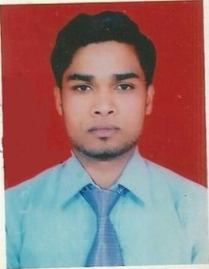
CURRICULUM VITAE
YOGESH RAI
Mobile: - 7500762232
E​-​Mail:​- yogeshrai7532@gmail.com

Career Objective:
profession and develop my managerial and technical skills. To build my career as an achiever, in an organization that provides freedom of thought and actions to enhance & use my knowledge for the growth of the organization.

Previous Organization:
- 45 days training in electricity board 33/11 kva power sub station division 2nd in rampur (u p)

Job Responsibilities (training):
- Transformer working control
- 33/11 kva bus bar and V C B control system
- Types of insulater HT&LT name
- 220 &440 ac supply 50 HZ & conductors wire name sub station

Academic Credentials:
- Passed DIPLOMA ( ELECTRICAL, ENGINEERING) first division from IFTM University Moradabad in 2014
- Passed B. TECH (ELECTRICAL.ENGINEERING) first division from IFTM University Moradabad in2017.
- Passed matriculation from U.P Board in year 2011.

Computer proficiency:
- C C C in NIELIT computer coures.

EXPERIENCE:
- 02 year 6 month in UP PCL 33/11 kva sub station division 1st Rampur .
- 06 months wheels india company ltd Rampur working as a QA engineer.
- Project in transformer.

Strength:
- An excellent team player.
- Effective communication skill.
- Flexibility and Willingness to learn.

Hobbies:
- Reading books.
- Playing cricket

Language Known:
- Hindi & English (Write Read ).

Personal Details:
Father Name : Mr. Rai singh
DOB : 04th may 1996
Nationality : Indian
Sex : Male
Marital Status : Married
Address : Vill Dalelnagar post saidnagar Distt Rampur.( u.p) 244901

Declaration:
I hereby declare that all the above information given by me is completely true at best extent of my knowledge.

Date: - YOGESH RAI
Place:- Rampur

